CSI STARS and Phil Brown’s Social Media Handles

An incredibly easy and effective way to gain exposure online is to use our handles (@CSI_Stars or @Stars_csi) and hashtags (#RecognizeYourStars, #CSISTARS) in Comments, Posts, Retweets and when Sharing content.

How?
LinkedIn and Facebook: @CSI STARS
Type in @CSI STARS and our handle when posting, commenting or sharing content. Our handle will pop up in window - accept and post!

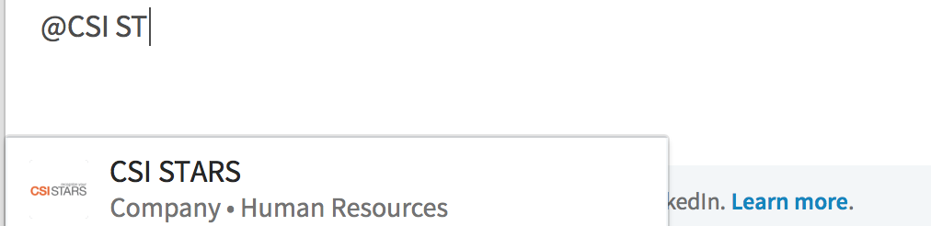

Twitter: @stars_csi
Retweet our posts using @stars_csi

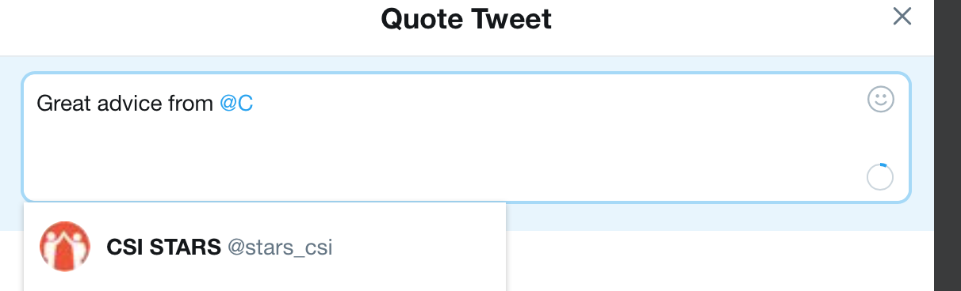

Instagram: @csi_stars
Post a picture and add a caption using #RecognizeYourStars hashtag or our handle @csi_stars
Some Suggested Hashtags to Use
#RecognizeYourStars | #ServiceAwards | #EmployeeRecognition
#CSISTARS | #Wellbeing | #Safety
#EmployeeRewards | #EmployeeAppreciation | #Culture
#Onboarding | #RecognitionIQ | #GiveThanks
#ServiceAnniversaries | #PersonalGifts | #EmployeeAwards

Want to reference Our Olympic Star Phil Brown?

Here are Phil’s handles:

LinkedIn- Phil Brown, Alpine Skiier

Twitter - @philbrown7

FB @philbrownski or Facebook.com/Philbrownski

Instagram – @philbrown77

