**Recognizing The Leukemia & Lymphoma Society’s everyday heroes**

CSI STARS is proud to be the official Recognition Partner for the **2019 LLS Man & Woman of the Year campaign**

*New York – April 2, 2019*. CSI STARS is proud to be named official Recognition Sponsor for The Leukemia & Lymphoma Society’s 2019 Man & Woman of the Year campaign.

Running until June 8th, thirty compassionate, well-connected men and women will be working tirelessly raising funds in their desire to find a cure for blood cancers. The winner of the Man and Woman of the Year title will be announced at a Grand Finale gala on June 8th and featured in *Forbes* magazine.

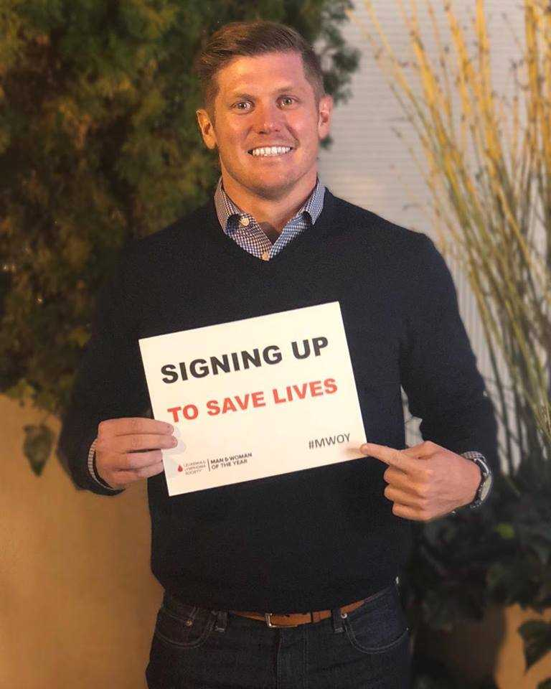CSI STARS is proud to support LLS and is rooting for our sales partner and all-around great guy, [Bert Johnson](https://csistars.com/rar/recognize-our-star/). Bert's history with LLS is a personal, all too common story. He lost his best friend and brother-in-law, Sam Haygood, in 2011 after a four year battle with cancer. Bert is competing in the Man of the Year challenge to honor Sam as well as two local children, the Boy and Girl of the Year, who are blood cancer survivors.    
  
**Too many stories like Bert's**  
One person in the United States is diagnosed with a blood cancer every three minutes. In 2018, 4,824 children, teens and adults under 20 years of age were diagnosed with leukemia. Blood cancers don’t discriminate.

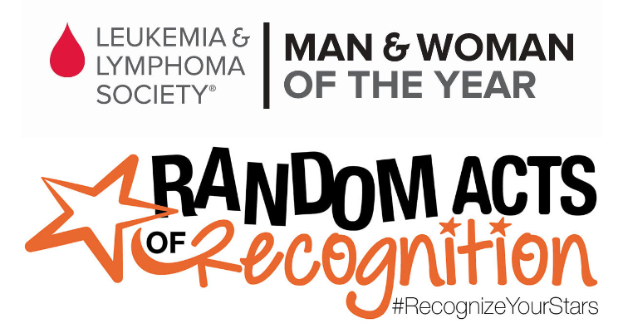CSI STARS is partnering with LLS to recognize survivors, fighters and the people who treat, support or inspire others in the name of fighting blood cancers. Each week we’ll be featuring one story of hope and courage from LLS as part of our [Random Act of Recognition](https://csistars.com/random-acts-of-recognition/) initiative. **Read, Share** and **Vote** on the weekly LLS stories to raise awareness and funds for this amazing organization.

[Donate](https://pages.mwoy.org/ga/atlanta19/bertjohnson) today to advance research and breakthrough therapies for blood cancer patients. Checkout the weekly LLS stories [here](https://csistars.com/random-acts-of-recognition/) and by following the LLS (@LLSusa) and CSI STARS on:

[](https://twitter.com/stars_csi)

@stars_csi @csi_stars @csi_stars

**About Us**



CSI STARS mission is to enable companies to recognize others in words, deeds and actions. [www.csistars.com](http://www.csistars.com)

Since 1979, we’ve been passionately delivering personalized recognition that improves employee engagement and business results. For more information on CSI STARS recognition solutions, contact Jim Brown at [jim.brown@csistars.com](mailto:jim.brown@csistars.com) or request a [short demo](http://csistars.com/get-demo/).

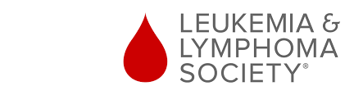

The Leukemia & Lymphoma Society (LLS) is the world's largest voluntary health agency dedicated to blood cancer.

The LLS mission is to cure leukemia, lymphoma, Hodgkin's disease and myeloma, and improve the quality of life of patients and their families. LLS funds lifesaving blood cancer research around the world and provides free information and support services. For more information or to make a donation, visit [www.lls.org](https://pages.mwoy.org/ga/atlanta19/bertjohnson)

**Media Contact:**

Lori McKnight

CSI STARS

T: 647 244 4764

E: lori@csistars.com