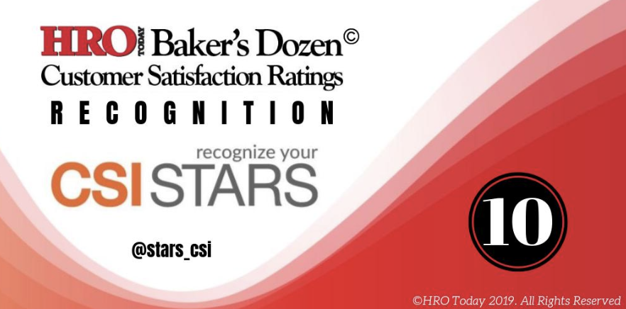



**RANKS AS A TOP 10 RECOGNITION PROVIDER IN NORTH AMERICA**

*New York – August 16, 2019*. CSI STARS, a global recognition and rewards partner, is thrilled today to announce being named to the top 10 list of recognition providers in North America by [*HRO Today’s* 2019 Baker’s Dozen.](https://www.youtube.com/watch?v=56AyHXOokps)

CSI STARS ranked 9th in Quality of Customer Service, 8th for Breadth of Service and placed 10th Overall. The top 13 recognition providers in the industry are determined based entirely on feedback from clients who complete an anonymous survey. Results are determined using statistical analysis and a weighted algorithm to ensure transparency.

“*Our team works incredibly hard to support our clients’ efforts to build cultures where every day recognition is the norm. We’ve seen first-hand how small acts of recognition when multiplied by many enhances cultures and boosts performance. A big thank you to our clients for taking the time to recognize their recognition people! We truly appreciate their partnership and are honored to support them in recognizing a multi-generational workforce in new and meaningful ways,*” says Steve Brown, President of CSI STARS.

*"The Baker’s Dozen Recognition Providers survey is the foremost gauge of employee recognition providers in the industry and is extremely well respected by HR professionals everywhere*," says Elliot Clark, CEO of SharedXpertise and HRO Today.

[Click here](http://www.hrotoday.com/news/engaged-workforce/performance-management-rewards/2019-bakers-dozen-customer-satisfaction-ratings-recognition/) to see the 2019 Baker's Dozen rankings for Employee Recognition.

Download [FREE recognition reminders](https://csistars.com/roar/) and check out how our clients are [recognizing their people](https://csistars.com/random-acts-of-recognition/)! Visit [www.csistars.com](http://www.csistars.com) and Follow us on :

[](https://www.instagram.com/csi_stars/) [](https://www.youtube.com/channel/UC5lTNnTZqmXCza6NDylkI4w/videos) [](https://twitter.com/stars_csi) [](https://www.facebook.com/csistars/)

@csi_stars CSI STARS @stars_csi @csi_stars

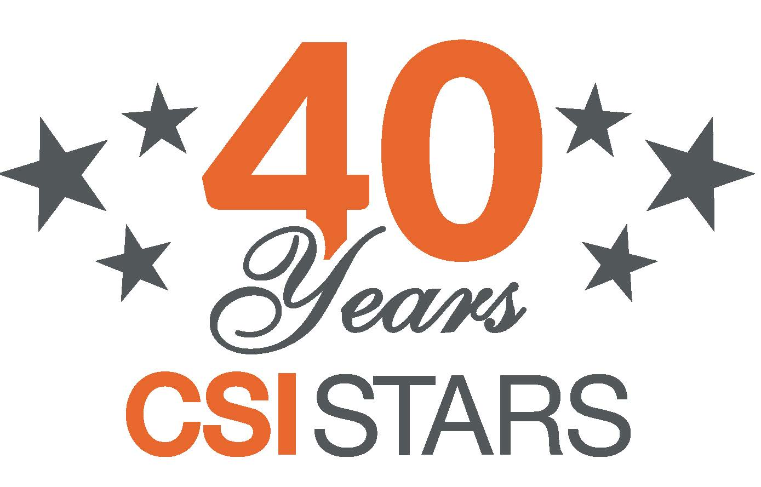



www.csistars.com

CSI STARS has been creating personalized recognition experiences employees value and remember since 1979. CSI STARS offers the best service award presentation materials in the industry, an easy to use digital recognition platform and rewards employees want. For more information contact Jim Brown at [jim.brown@csistars.com](mailto:jim.brown@csistars.com) or request a [short demo](http://csistars.com/get-demo/).

**Media Contact:**

Lori McKnight

CSI International

T: 647 244 4764

E: lori@csistars.com