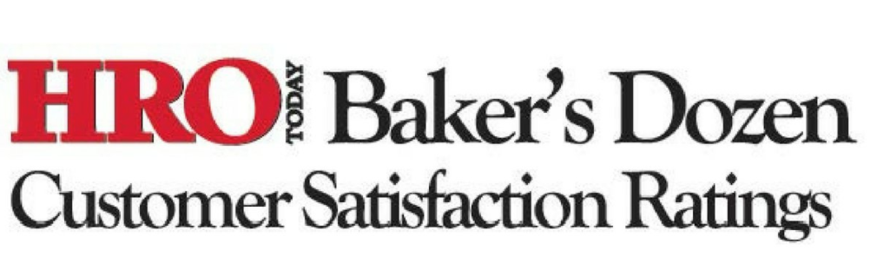



**CSI STARS RANKS 8th FOR QUALITY OF CUSTOMER SERVICE**

**In the Recognition and Rewards Industry**

*New York – August 12, 2020*. CSI STARS has been ranked as a top provider of customer service in the recognition and rewards industry for the third year in a row. A big thanks to our awesome clients for voting us into the top 11 list of recognition providers in North America by [*HRO Today’s* 2020 Baker’s Dozen Survey.](https://www.youtube.com/watch?v=xTHIdkpvKuI&feature=youtu.be)

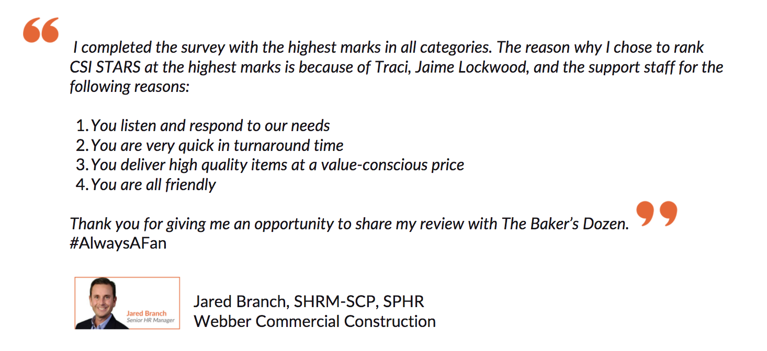CSI STARS ranked **8th in Quality of Customer Service**, **7th for Breadth of Service** and placed **11th Overall**. The Baker’s Dozen top recognition providers in the industry are determined based entirely on feedback from our clients who complete an anonymous survey. Results are determined using statistical analysis and a weighted algorithm to ensure transparency.

“*A big thanks to Jared and all our clients for recognizing their recognition people! We appreciate their trust and partnership. It’s been a challenging and stressful year for the world’s workforce and we are honored to help our hardworking clients engage and support their people in meaningful ways at home, the office and on the frontlines,*” - Steve Brown, President of CSI International Inc.

[Click here](https://www.hrotoday.com/bakers-dozen-ranking-recognition/) to see the 2020 Baker's Dozen rankings for Employee Recognition.

**Take 30 Seconds to Pay Thanks Forward**

Recognition has a way of calming the nerves and lifting spirits. **Show your gratitude** to a colleague, healthcare hero or essential service professional in your life by sending an **inspiring eCard** at [www.csistars.com/heroestozero](http://www.csistars.com/heroestozero). For every eCard sent, CSI STARS will donate $1 to [Johns Hopkins Medicine](https://www.hopkinsmedicine.org/coronavirus/giving.html) in their race for a COVID-19 vaccine.

[](https://www.instagram.com/csi_stars/) [](https://www.youtube.com/channel/UC5lTNnTZqmXCza6NDylkI4w/videos) [](https://twitter.com/stars_csi) [](https://www.facebook.com/csistars/)

@csi_stars CSI STARS @stars_csi @csi_stars



www.csistars.com

CSI STARS has been creating personalized recognition experiences since 1979. While we are best known for our value-added service anniversary platform with social tools and tax-compliant awards – we do much more. Our experienced consultants help you integrate **microlearning** with your digital **recognition tools** to deliver hard and soft skills training to everyone, from anywhere on any device. Experience this personally by contacting Lori McKnight at [lori@csistars.com](mailto:lori@csistars.com) or [www.csistars.com](http://www.csistars.com)

**Media Contact:**

Lori McKnight

CSI International

T: 647 244 4764

E: lori@csistars.com